LAB # 7
Generics in Java
Lab Task:
Write a program that takes integer array, double array and float array. Make a generic function that performs subtraction on array element:
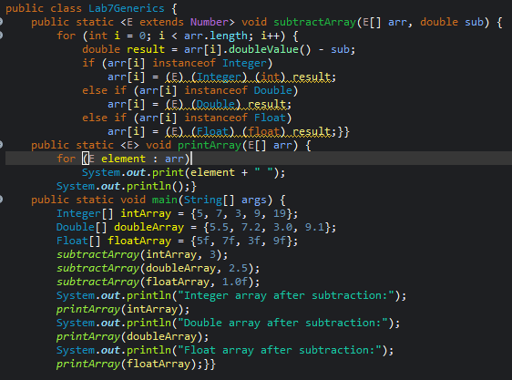

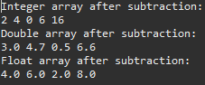

GITHUB SCREENSHOT:

